Week 3. Functions

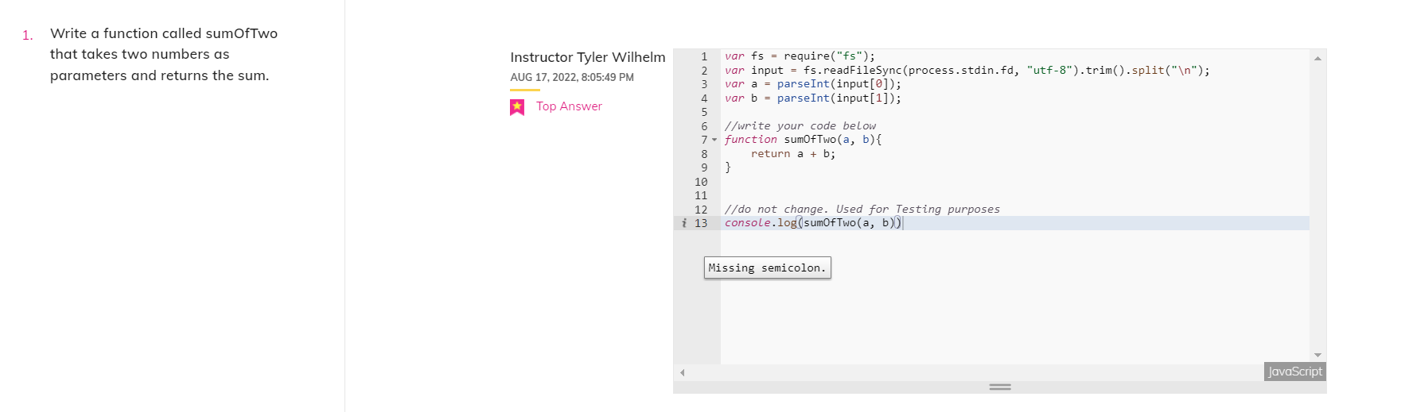

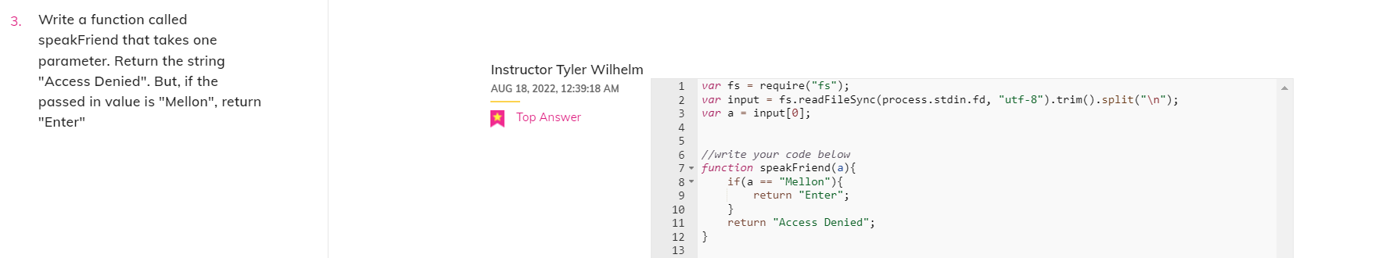



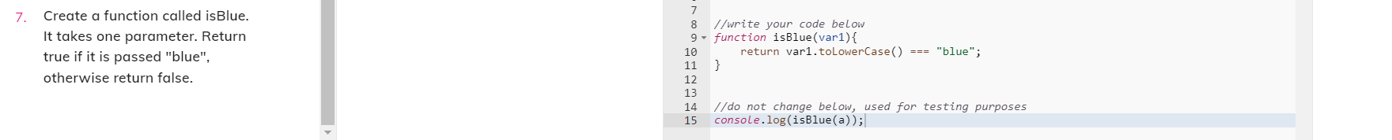

Week 3 – Arrays

